USING OPENWATER TO SUBMIT PERFORMANCE THESPY EVENTS, PLAYWRITING, STATE-QUALIFYING SHORT FILM, AND SCHOLARSHIPS:

TEACHERS MUST MAKE ALL SUBMISSIONS FOR YOUR STUDENTS.
If you do not have an account in Community Hub, follow these instructions: When you go to create an application in OpenWater, you should be redirected to the Community Hub page. On this page you can click "Don't have an account?" to create one (using the same email address as you plan to do in OpenWater). Once you have done that, you can use SSO to access OpenWater. This is also true for directors of non-Thespians troupes.

You may watch the following video for a walkthrough of the information listed below:
https://youtu.be/Ds2GK-UmMIk?si=C2NxckprhNAi06Ys

If you have previously created an account or have a chartered troupe, when you are directed to Community Hub they should enter the email address currently connected to EdTA's database, click "forgot your password?" and update their password for Community Hub, then proceed to Open Water.

Go to: https://edta-chapter-events.secure-platform.com/a/organizations/WestVirginia/home

You will see:
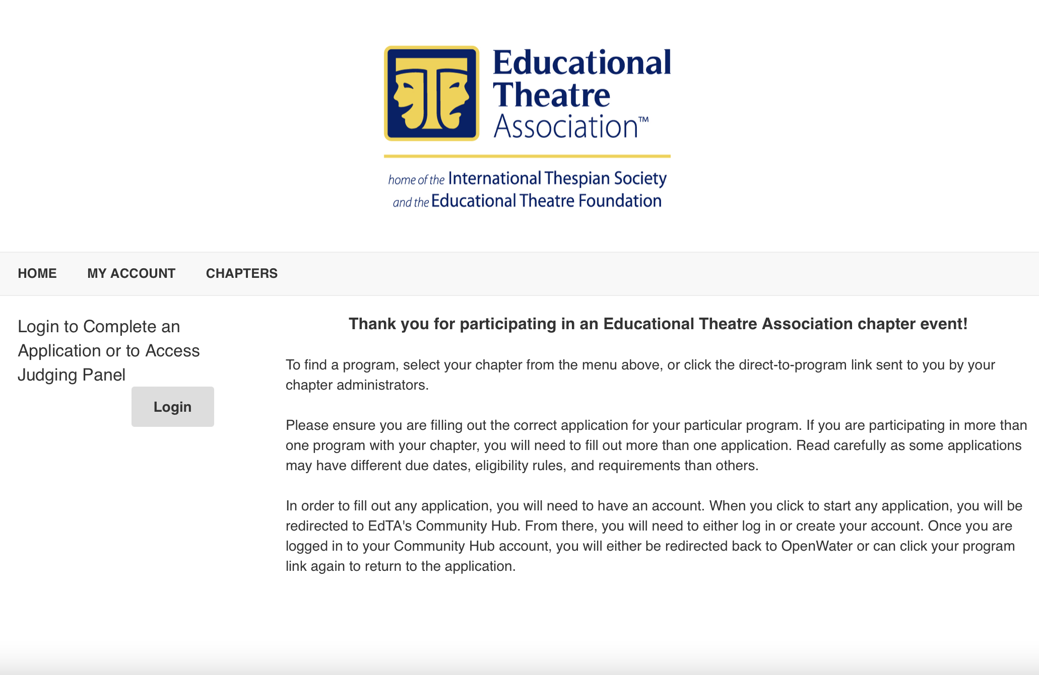

After creating a log-in and logging in, you will see:

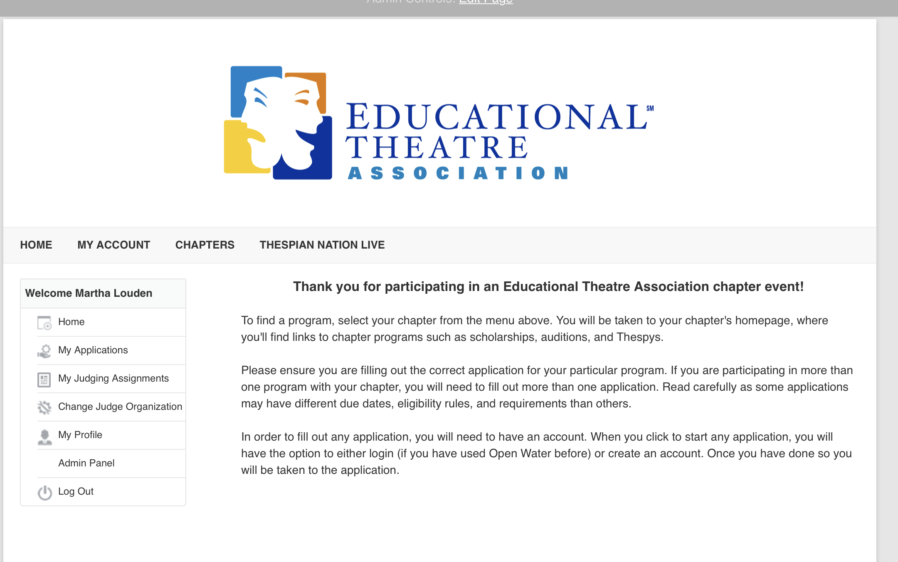

Hover over the CHAPTERS and scroll to find West Virginia – click on that. Then you will see something like this, except it will list in blue:
West Virginia Thespian Scholarships 2026
WV Thespian State Thespian Festival 2026 - for ALL performance Thespys, playwriting, and short film entries.

This image is from 2020. What you see WILL NOT look like this This is here just to give you an idea.

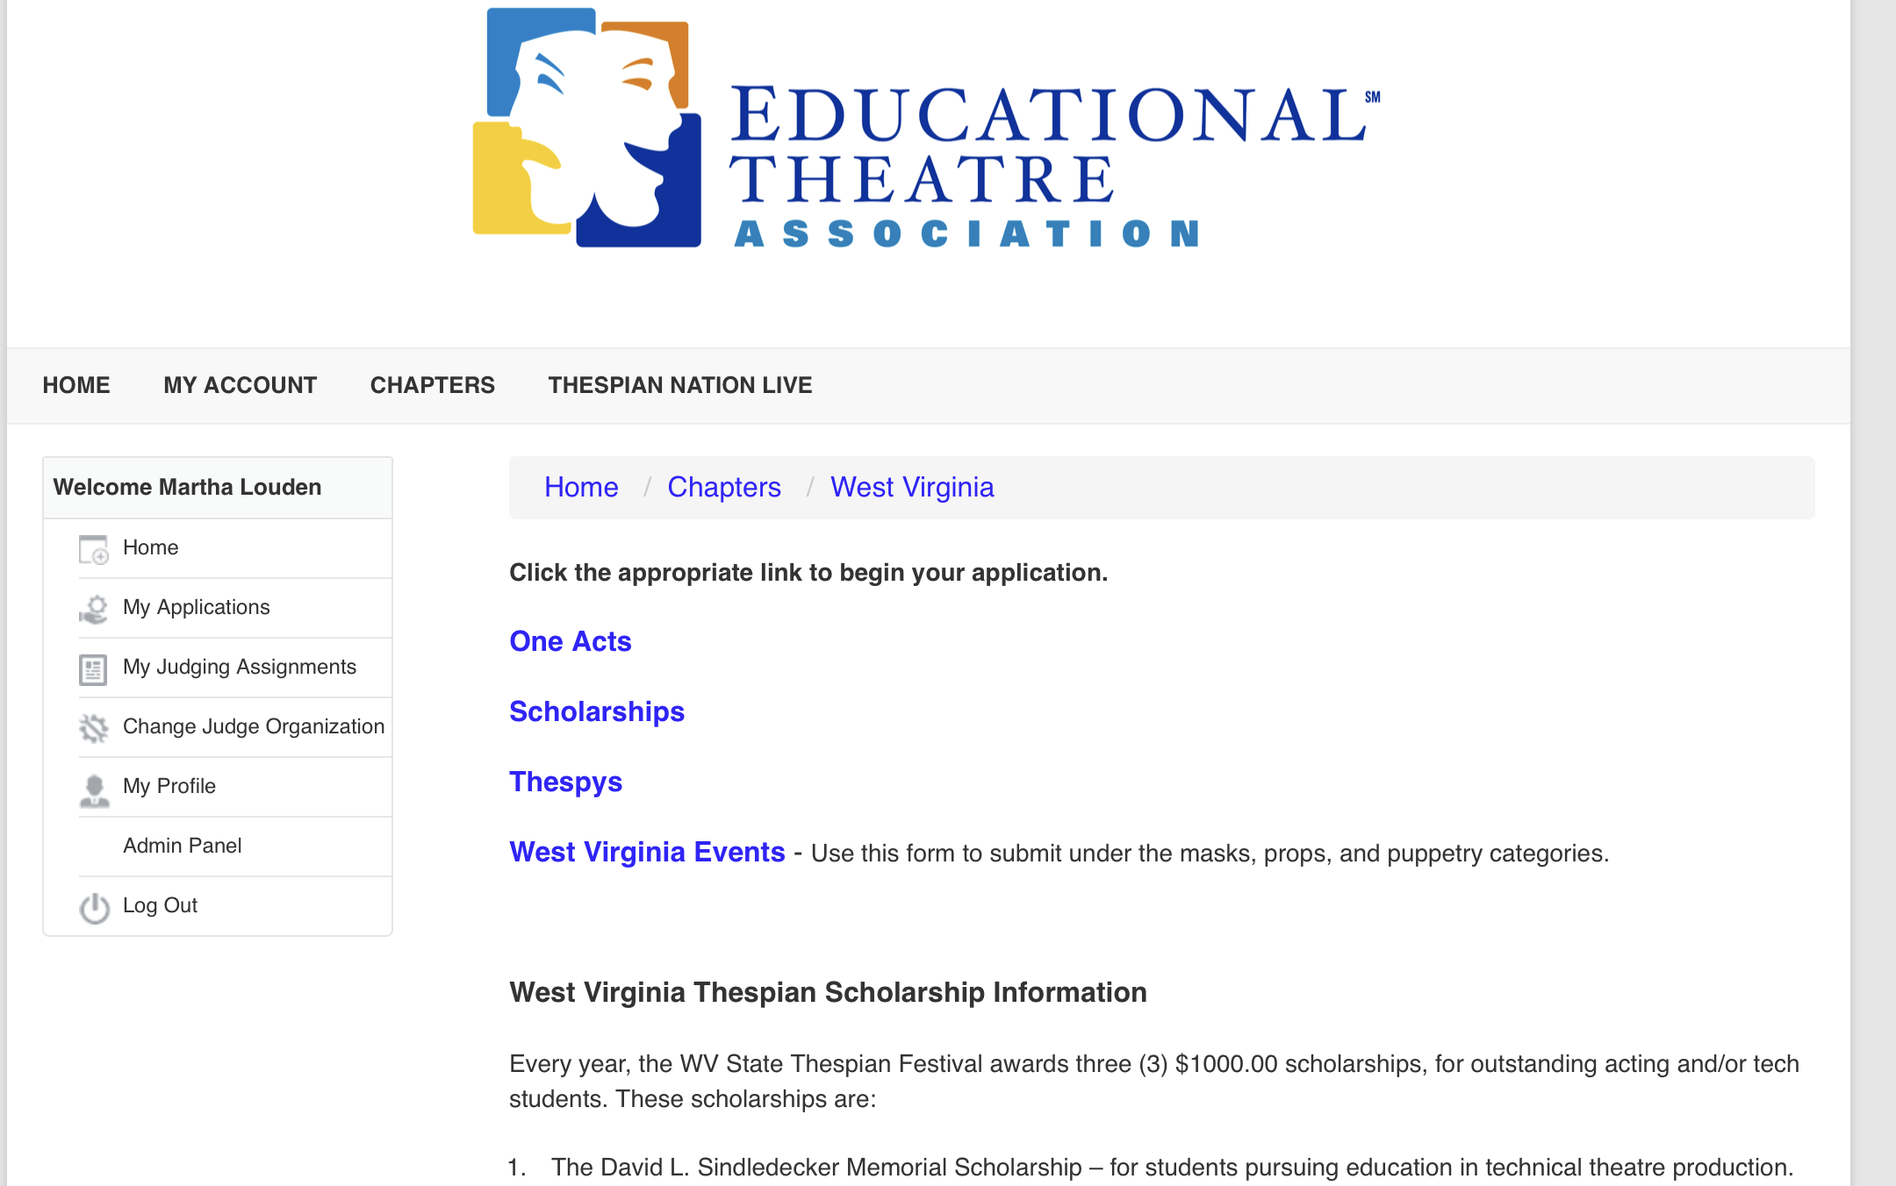

From here, click on the appropriate link and just fill in the form that follows. Be sure to fill in all the blanks and to upload all videos and/or documents required for the event. If you do not have a chartered troupe, just leave that blank empty.

